Workplace Emergency Plan

Effective Date
December 01, 2021

TABLE OF CONTENTS

Introduction……………………………………………………………………………………………… 3
Calling 911…….………………………………………………………………………………….…...... 3
Roles & Responsibilities………………..……………………………………………………………… 4
Emergency Coordinator………………… ……....…………………………….…….….…… 4
Zone Leader……………………………………................................................................. 5
Employee Aides.……………..………………………………..………….…........................ 5
All Other Employees…………………………………………………………………………. 5
Medical Emergencies……………………………………………………………….…….…............ 6
Bomb Threat ...………………………………………………………………………..………..…….... 6
Active Shooter ………………………………………………………………………………………..... 6
Natural Disasters……………………………………….……………………………....…….............. 7
Chemical Spill………………………………………….……………..............….………................... 8
Fire….……………………………………………………………….………..……………................... 8
After Action Review.……………………………………………………….…………………….……. 9
Bomb Threat Card…………………………………………………………………………….……… 10
Evacuation & Medical Equipment Map……………………………………………………………… 11

- INTRODUCTION

The Workplace Emergency Plan establishes guidelines for reasonably foreseeable workplace emergencies that occur within, or immediately affect City office buildings. Because each workplace emergency involves unique circumstances, this plan provides general guidance. It is not intended to be a set of requirements.

Employees should be familiar with the plan before an emergency occurs. Advance training and practice are critical for responding appropriately to workplace emergencies. Thoughtful actions based on an assessment of the specific situation is always required when responding to an emergency. It is also important to note that emergency guidelines do not necessarily represent a sequential series of steps. Safety and health are the overriding priorities in all emergency situations.

The Workplace Emergency Plan includes all major City structures such as the City Hall, Fire Station and Police Station. Similar precautions should be taken at the Animal Shelter and in the Public Works Operations Buildings. Emergency responders will react accordingly and so will not necessarily follow the protocols of this plan.

Differing emergencies require differing responses. A fire or bomb threat will likely require evacuation of the building. However, a tornado threat may require that employees take shelter within the building. Earthquakes require both taking immediate nearby shelter within the building and then possibly evacuating the building.

Protective actions for life safety include:

- Evacuation
- Sheltering
- Shelter-In-Place
- Lockdown

The goal of the Workplace Emergency Plan is to help prevent injury and save lives by being as prepared as possible. Actions taken in the initial minutes of an emergency are critical. A prompt warning to employees to evacuate, shelter or lockdown can save lives. An immediate call for help to public emergency services that provides full and accurate information will help the dispatcher send the right responders and equipment. An employee trained to administer first aid or perform CPR can be lifesaving. Prompt action by employees with knowledge of building and water systems can help minimize damage to the facility.

- CALLING 911

Any City employee is authorized to call 911 in the event of an emergency. Employees should also notify the Zone Leader or their immediate supervisor so they can begin the Workplace Emergency process which includes notifying other employees. Please review the Roles and Responsibilities section of this policy.

911 personnel will ask for pertinent information so respond as completely as possible. Some of the information they may request is as follows:

- Your name and location
- Type of emergency

DO NOT HANG UP FIRST. Let emergency personnel hang up first. After the call, station someone to direct emergency responders to the scene of the emergency if possible.

- ROLES & RESPONSIBILITIES

One of the most critical elements in an effective workplace emergency plan is training employees so they know what to do to protect themselves and others. Another critical element is quickly alerting employees of the emergency what action is needed.

The Workplace Emergencies Plan establishes specific roles and responsibilities for creating, maintaining and operating the Plan including employee training. The Zone Leader role is intended to facilitate quick response to emergencies and to provide direction to keep employees safe. All employees should know these procedures, most notably the Zone Leader responsibilities. Employees should be prepared to take appropriate action to keep themselves and others as safe as possible.

Key roles include the Emergency Coordinator, Zone Leader and Employee Aides.

- Emergency Coordinator

The Emergency Coordinator is responsible for the overall plan for the City. The Emergency Coordinator is usually the Fire Chief or other safety officer.

- Non-Emergency Responsibilities

- Ensure that the Workplace Emergency Plan is available to all employees
- Conduct training exercises as needed to optimize employee response to various emergencies
- Conduct and document an After-Action Review following any emergency event or training exercise and make revisions as needed
- Review and update the Workplace Emergency Plan at least annually
- Ensure personnel are assigned to all Workplace Emergency Plan positions for each major City building
- Compile a floor map of each building showing building entrances, the locations of emergency equipment and the locations of controls for building utility and protection systems and make the information accessible to emergency responders
- Compile instructions for operating all building systems and equipment and make the information accessible to emergency responders
- Provide a copy of the plan to the public emergency services that would respond to your facility and others with responsibility for building management and security.
- Store the plan with other emergency planning information such as chemical Material Safety Data Sheets (MSDS), which are required by Hazard Communication or “right to know” regulations.
- Verify the availability of emergency equipment such as AED’s fire extinguishers
- Maintain emergency medical, sustenance and other supplies as warranted in each City structure recommendations on contents can be found at http://emergency.cdc.gov/disasters/earthquakes/supplies.asp

- Duties/Responsibility During an Emergency

During an emergency, the Emergency Coordinator assists the Zone Leaders and verifies that appropriate actions are taken.
- Call 911 to verify that first responders have been notified of the emergency
- Notify Facilities Maintenance or other appropriately trained personnel so that action can be taken such as shutting down the HVAC, water and/or other systems
- Collect information from Zone Leaders (usually via cell phone) and serve as the primary point of contact for emergency responders

- Zone Leader

Zone Leaders are the responsible for quickly responding to emergencies and for providing direction to keep employees as safe as possible.

A Zone Leader and a backup will be assigned to a specific area of each building. Zone Leaders are usually the department head or senior leader in that area of the building. Other employees with appropriate training may step in for the Zone Leader or assist as needed.

- Non-Emergency Responsibilities

- Know emergency medical techniques such as first aid, first aid for severe trauma (FAST) and CPR
- Understand the building's emergency procedures and be prepared to assume his/her responsibilities promptly and calmly in an emergency
- Be aware of the location and how to operate emergency equipment such as AEDs and fire extinguishers
- Know the location of emergency medical, sustenance and other supplies
- Walk around the building and be familiar with exits and verify they are marked with exit signs and there is sufficient lighting so people can safely travel to an exit. If you find anything that blocks an exit, have it removed.
- Enter every stairwell, walk down the stairs, and open the exit door to the outside. Locate safe places away from the building so you may direct employees to this area in an evacuation.
- Be aware of areas in the building that provide the best shelter in the event of an emergency such as a tornado
- Maintain an accurate roster of all members assigned to his/her zone, which will be updated at least twice a year and upon the arrival of any new personnel

- Duties/Responsibilities During an Emergency

- Call 911 and report the emergency or direct someone to do so
- Notify the other Zone Leaders of the emergency
- Operate emergency equipment such as AEDs and fire extinguishers
- Use and dispense emergency medical, sustenance and other supplies
- Initiate and coordinate the orderly movement of employees to evacuate, shelter or lockdown
- In an evacuation, direct people to exit via the stairwells; remind them NOT to use the elevators
- Verify that your entire Zone is vacated in the event of an emergency requiring evacuation or sheltering
- Obtain a list of employees in a sheltering emergency.
- Shut off air vents, gas, electricity or water as necessary to eliminate hazards and reduce damage

- Employee Aides

Any employee who may have difficulty evacuating or moving to shelter should notify their supervisor. The supervisor who will assign an Employee Aid, or will notify the Zone leader to do so. The Employee Aid will assist that employee in the event of an emergency. Any employee who see another employee having difficulty evacuating should immediately provide assistance.

- All Other Employees

All employees are expected to be familiar with the Workplace Emergency Plan. This includes but is not limited to:

- How to respond to varying emergencies requiring evacuation, sheltering, sheltering-in place or lockdown
- Who in the building is a Zone Leader or who is trained in medical techniques such as first aid, first aid for severe trauma (FAST) and CPR
- The location of first aid supplies
- The location of fire extinguishers and AEDs and who in the building is trained to operate them
- Knowing that you are authorized to call 911
- The signals for emergency action; most will be verbal commands
- The routes and exits to evacuate the building
- The routes to take shelter within the building
- Following directions in the event of an emergency
- How to ensure their own safety while assisting others when possible

- MEDICAL EMERGENCY

- Call 911 or direct someone to do so; provide as much information as possible
- Contact the Zone Leader or trained employees to respond to the victim’s location and bring a first aid kit or Automated External Defibrillator (AED)
- Only trained personnel should provide first aid assistance
- Do not move the victim unless the victim’s location is unsafe
- Take precautions to prevent contact with body fluids and exposure to blood borne pathogens
- Meet the ambulance at the nearest entrance or emergency access point; direct them to victim(s)

- BOMB THREAT

- If you receive a Phone Bomb Threat
- Stay calm – do not alarm others
- Fill out the Bomb Threat Card (See Attachment 2) to assist emergency responders
- Employees whose primary role is answering phones should know how to quickly access this card
- Notify your supervisor or Zone Leader who will report the threat to law enforcement by calling 911
- If your supervisor or Zone Leader is not present, you make the call to 911
- The decision to evacuate the building will be made by the Zone Leader and law enforcement personnel
- Take the Bomb Threat Card with you if the building is evacuated

- If you find a Written Bomb Threat
- Remain calm and leave the message where it is found
- Do not handle the document any more than necessary to preserve fingerprints and other evidence
- Do not alarm others
- Notify your supervisor or Zone Leader who will report the threat to law enforcement by calling 911
- If your supervisor or Zone Leader is not present, you make the call to 911
- Do not give information to anyone except supervisor, Zone Leader and law enforcement personnel.
- Follow the evacuation instructions if asked to evacuate

- ACTIVE SHOOTER

An act of violence in the workplace could occur without warning. Active shooter response is continually being revised and improved on a regular basis. Periodic training from the Police Department is necessary to stay current on how to respond. Listed below are guidelines that supplement ongoing training.

Multiple employees should be trained to broadcast a lockdown warning to other employees as soon as it is safe to do so.

As with any emergency, try to remain calm and call 911 when it is safe to do so.

Follow these steps: Avoid, Deny and Defend

- Avoid
- Try to determine the location of the shooter and escape away from the shooter
- Keep in mind that the shooter may be outside and shooting through windows
- Leave your belongings behind
- Keep your hands visible

- Deny
- Hide in an area out of the active shooter’s view
- Avoid windows and doorways
- Block entry to your hiding place and lock the doors

- Defend
- As a last resort and only when your life is in imminent danger, attempt to incapacitate the active shooter
- Act with physical aggression and throw items at the shooter
- Don not fight fair; use anything you can as a weapon

When Law Enforcement arrives on the scene, follow these instructions:

- Remain calm and follow the officers’ instructions
- Immediately raise your hands and spread your fingers

Information you should provide to Law Enforcement:

- Location of the shooter if known
- Number of shooters
- Physical description of the shooter(s)
- Number and type of weapons
- Number of potential victims

- NATURAL DISASTERS

Zone leaders should provide instructions similar to the following:

- Tornado
- Remain as calm as possible
- Seek shelter inside the building
- Assist other people in finding a shelter area
- Preferred shelter areas are:
  - small interior rooms without windows on the lowest floor
  - hallways on the lowest floor away from doors and windows
  - windowless rooms constructed with reinforced concrete, brick, or block
- Stay away from outside walls and windows.
- If the building is breeched, use your arms to protect your head and neck
- Call 911 if there are injuries and advise trained personnel such as a Zone Leader
- Remain sheltered until you’re sure it’s safe or a Zone Leader, First Responders or emergency broadcast messages announce that the immediate threat is over.

- Earthquake
- Remain as calm as possible
- Seek immediate shelter under a desk or table
- Stay away from windows to avoid being injured by shattered glass
- Stay away from overhead fixtures, windows, filing cabinets, and electrical power
- Use your arms to protect your head and neck
- Stay indoors until the shaking stops and you are sure it is safe to exit
- Call 911 if there are injuries and advise trained personnel such as a Zone Leader
- Use the stairs rather than an elevator in case there are aftershocks, power outages, gas leaks, fire or other damage
- Be aware that utilities such as gas, power, and water lines may be damaged and immediately report any damage to the Zone Leader
- Assist other people in finding a safe place
- Remain evacuated a safe distance from the building or sheltered inside if so directed until the Zone Leader or First Responders announce that the immediate threat is over.

- Flood
- Remain as calm as possible
- Be ready to take shelter on higher levels of the building or evacuate as directed by the Zone Leader, First Responders and/or emergency broadcast messages
- Avoid walking through flood water if possible
- Remain sheltered until the Zone Leader, First Responders or emergency broadcast messages announce that the immediate threat is over.

- Blizzard
- Remain as calm as possible
- Stay indoors
- If there is no heat:
  - Close off unneeded rooms or areas
  - Stuff towels or rags in cracks under doors
  - Cover windows at night
  - Eat and drink because food provides the body with energy and heat and fluids prevent dehydration
  - Remain sheltered until the Zone Leader, First Responders or emergency broadcast messages announce that the immediate threat is over.

- CHEMICAL SPILL/TOXIC AIR
- Remain calm and await instructions from the Zone Leader
- If your supervisor or Zone Leader is not present, call 911
- Close all exterior doors and windows
- Seek shelter inside the building
- Assist other people in finding a shelter area
- Preferred shelter areas are:
  - The core of the building away from windows and doors
  - Move to the second or higher floor and avoid the basement
- Remain sheltered until the Zone Leader or First Responders or emergency broadcast messages announce that the immediate threat is over.

- FIRE

- Remain calm and await instructions from the Zone Leader
- If your supervisor or Zone Leader is not present, call 911
- Assist with fire extinguishers only if you are trained to do so
- Evacuate the building if directed to do so
- Do not use the elevators
- Assist other people in evacuating the building
- Move a safe distance away from the building
- Do not block roadways or doorways or in any way restrict access by emergency responders and their vehicles
- The Zone Leaders or First Responders will verify that the building is vacant and then provide further instructions

ADOPTED by the City Council on the 1st day of December, 2021.

Mayor: Signed Copy Available in HR Date: _______________________
Attest: ___________________________
City Clerk

ATTACHMENT 1 - AFTER ACTION REVIEW

Date of Event: ________________

Type of Event: ________________

Time of Notice: ________________

Time of 911 call (or practice call): _________________

Time fully evacuated or fully in shelter rooms: ________________

Net time to safety_____________________

Any issues with the efficiency or safety of emergency escape routes:

Any issues with the efficiency or safety of routes to shelter in place locations:

Any issue with Zone Leaders being confident that the building is vacated:

Any issues with employees remaining behind to operate/conduct critical operational requirements before they evacuate or move to shelter:

Any issues with Zone Leader assignment structure or with carrying out their duties:

Any other improvements or equipment needed:

Attachment 2 - Bomb Threat Card

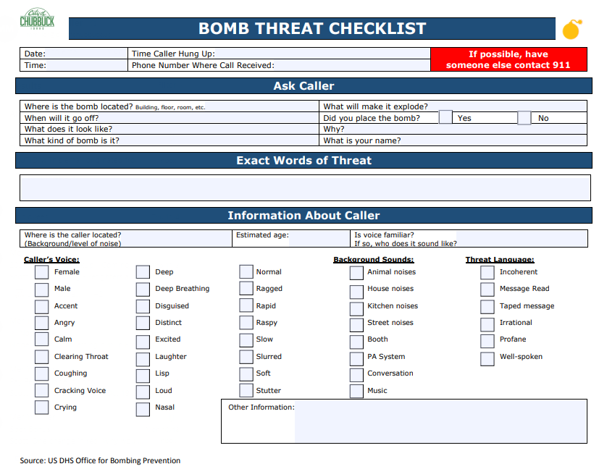

Attachment 3 – EVACUATION PLAN