Updated 11/09/2022
 | 1) PORSHIA HARTMAN |  |  |  |  |  |  |  | 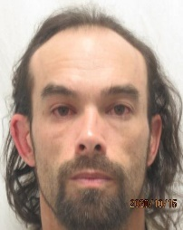 | 6) antonio stone
 | Age 32 years |  | 5’05” |  | 137 # |  |  |  |  | Age 41 years |  | 5’07” | 140 #
 | Caucasian |  | Hazel |  | Brown |  |  |  |  | Hispanic |  | Brown | Brown
 | Delivery of Fentanyl |  |  |  |  |  |  |  |  | Fail To Provide DNA Sample
 | Pocatello Police Department |  |  |  |  |  |  |  |  | Pocatello Police Department
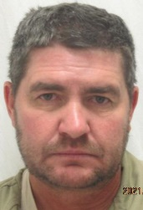 | 2) marc porter |  |  |  |  |  |  |  | 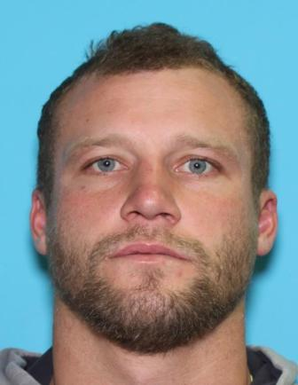 | 7) david pasquella
 | Age 51 years | 5’05” |  | 150 # |  |  |  |  |  | Age 34 years |  | 5’11” |  | 200 #
 | Caucasian | Brown |  | Brown |  |  |  |  |  | Caucasian |  | Blue |  | Sandy
 | Excessive DUI  Pocatello Police Department |  |  |  |  |  |  |  |  | Possession of Cocaine  Pocatello Police Department
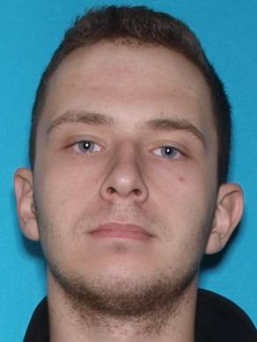 | 3) travis odom |  |  |  |  |  |  |  |  | 8) Cara Johnson
 | Age 22 years | 6’00” |  |  |  | 170 # |  |  |  | Age 26 years | 5’09” |  | 157 #
 | Caucasian | Blue |  |  |  | Brown |  |  |  | Caucasian | Blue |  | Blonde
 | Attempted Strangulation  Pocatello Police Department |  |  |  |  |  |  |  |  | Injury to a Child  Pocatello Police Department
 | 4) david gunderson |  |  |  |  |  |  |  | 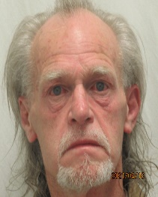 | 9) james ballou
 | Age 41 years | 6’00” |  |  |  | 170 # |  |  |  | Age 69 years | 5’09” |  |  | 170 #
 | Caucasian | Green |  |  |  |  | Blond |  |  | Caucasian | Blue |  |  | Grey
 | Aggravated Battery  Pocatello Police Department |  |  |  |  |  |  |  |  | Fail to Register as Sex Offender  Bannock County Sheriff’s Office
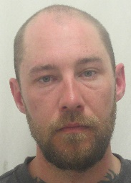 | 5) james murietta |  |  |  |  |  |  |  | 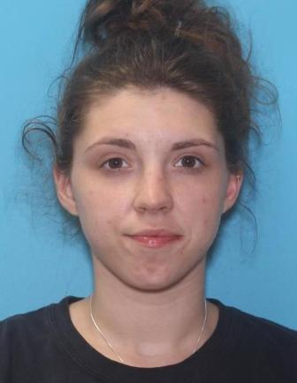 | 10) day Will
 | Age 36 years | 5’10” |  |  |  | 150 # |  |  |  | Age 23 years | 5’05” |  | 154 #
 | Caucasian | Hazel |  |  |  | Brown |  |  |  | Caucasian | Brown |  | Brown
 | Strangulation  Pocatello Police Department |  |  |  |  |  |  |  |  | Injury to a Child  Pocatello Police Department

